附件2：申请意向书





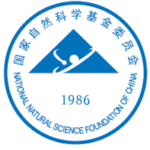
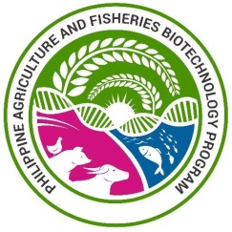

NEWTON FUND SWINE & POULTRY RESEARCH INITIATIVE

Letter of Intent

- Please provide the details of the proposed project team (principal and co-investigators) in the UK and partner countries, indicatingthe lead investigator per country in bold font.

Country | Name | Organisation | Department/Division

- Proposed Project title:

- Which of the challenge areas of the call will your proposal address(tick all that apply)?

☐ Host pathogen interactions
☐ Microbiology
☐ Epidemiology
☐ Disease management and control

- Please state which animal species your proposal will focus on.

- Please provide a brief description of your proposed research project (max 200 words)

